Rest API NOTES WITH ASP.NET

Part 1
1. Create the dotnet web api by typing [dotnet new webapi]
2. Install the c-sharp extension in visual studio code
3. Inside the root folder, create a model folder
4. Right click on the model folder and with the help of the c-sharp extension, create a class file called [MallModel.cs]

Paste this code in the MallModel.cs file
using System;
using System.Collections.Generic;
using System.Linq;
using System.Threading.Tasks;

namespace DotNetApi.Models
{
public class MallModel
{
public int Id { get; set; }
public string Name { get; set; } = "Name";
public DateTime created { get; set; }
}
}

Inside the Controller Folder, right click on it and create a ApiController called ModelController.cs paste the following code in it

using System;
using System.Collections.Generic;
using System.Linq;
using System.Threading.Tasks;
using DotNetApi.Models;
using Microsoft.AspNetCore.Mvc;

namespace DotNetApi.Controllers
{
[ApiController]
[Route("api/MallController")]
public class MallController:ControllerBase{
[HttpGet]
public IEnumerable<MallModel>GetModel(){
return new List<MallModel>{
new MallModel{Id=1, Name="Kofi"},
new MallModel{Id=2, Name="Ama"},
new MallModel{Id=3, Name="Yaa"},
new MallModel{Id=4, Name="Akos"},
new MallModel{Id=5, Name="Kwame"},
new MallModel{Id=6, Name="Kojo"},
};
}
}
}

PART 2

We may have some field in the model that we don't want to expose it to the user. So we can just create a DTO which will function as a wrapper between the model and the controller

in the model folder, create a folder named DTO and add this code to it

# MallDTO.cs
using System;
using System.Collections.Generic;
using System.Linq;
using System.Threading.Tasks;

namespace DotNetApi.Models.Dto
{
public class MallDto
{
public int Id { get; set; }
public string Name { get; set; } = "Name";
}
}

# The new controller class will be this
# MallController.cs

using System;
using System.Collections.Generic;
using System.Linq;
using System.Threading.Tasks;
using DotNetApi.Models.Dto;
using Microsoft.AspNetCore.Mvc;

namespace DotNetApi.Controllers
{
[ApiController]
[Route("api/Mall")]
public class MallController : ControllerBase
{
[HttpGet]
public IEnumerable<MallDTO> GetMall(){
return new List<MallDTO>{
new MallDTO{Id = 1, Name = "Solomon"},
new MallDTO{Id = 2, Name = "Whiskey"},
new MallDTO{Id = 3, Name = "Jack"},
new MallDTO{Id = 4, Name = "Jill"},
new MallDTO{Id = 5, Name = "Max"},
new MallDTO{Id = 6, Name = "Charlie"},

};

}
}
}

PART 3
# Create a Data folder in the root project directory and add a class MallStore
# Inside the MallStore class, add the following code

# MallStore.cs
using System;
using System.Collections.Generic;
using System.Linq;
using System.Threading.Tasks;
using DotNetApi.Models.Dto;

namespace DotNetApi.Data
{
public static class MallStore
{
public static List<MallDTO> MallList = new List<MallDTO>{
new MallDTO{Id = 1, Name = "Solomon"},
new MallDTO{Id = 2, Name = "Whiskey"},
new MallDTO{Id = 3, Name = "Jack"},
new MallDTO{Id = 4, Name = "Jill"},
new MallDTO{Id = 5, Name = "Max"},
new MallDTO{Id = 6, Name = "Charlie"},

};
}
}

# The mall controller will look like this:
MallController.cs

using System;
using System.Collections.Generic;
using System.Linq;
using System.Threading.Tasks;
using DotNetApi.Data;
using DotNetApi.Models.Dto;
using Microsoft.AspNetCore.Mvc;

namespace DotNetApi.Controllers
{
[ApiController]
[Route("api/Mall")]
public class MallController : ControllerBase
{
[HttpGet]
public IEnumerable<MallDTO> GetMall(){
return MallStore.MallList;

}
}
}

PART 4
In this section, we are going to perform CRUD operation, which is Create, Read, Update, Delete

For the Read Section, This will be the Code inside the MallController

[HttpGet]
public IEnumerable<MallDTO> GetMall(){
return MallStore.MallList;

}

[HttpGet("Id")]
public MallDTO GetOneMall(int Id){

return MallStore.MallList.FirstOrDefault(x=>x.Id == Id);

}

The HTTP REQUEST MUST HAVE A RESPONSE CODE WHICH WILL BE
[HttpGet]
public ActionResult<IEnumerable<MallDTO>> GetMall(){
return Ok(MallStore.MallList);

}

[HttpGet("Id")]
public ActionResult<MallDTO> GetOneMall(int Id){
if (Id <= 0){
return BadRequest();
}
var Mall = MallStore.MallList.FirstOrDefault(x=>x.Id == Id);
if (Mall == null){
return NotFound();
}
return Ok(Mall);

}

We can further add dynamic status code to the Http Get so that it will return the various Status codes

[HttpGet]
[ProducesResponseType(StatusCodes.Status200OK)]
public ActionResult<IEnumerable<MallDTO>> GetMall(){
return Ok(MallStore.MallList);

}

[HttpGet("Id")]
[ProducesResponseType(StatusCodes.Status200OK)]
[ProducesResponseType(StatusCodes.Status400BadRequest)]
[ProducesResponseType(StatusCodes.Status404NotFound)]

public ActionResult<MallDTO> GetOneMall(int Id){
if (Id <= 0){
return BadRequest();
}
var Mall = MallStore.MallList.FirstOrDefault(x=>x.Id == Id);
if (Mall == null){
return NotFound();
}
return Ok(Mall);
}

For the Create Section, This will be the Code inside the MallController

[HttpPost]
[ProducesResponseType(StatusCodes.Status200OK)]
[ProducesResponseType(StatusCodes.Status400BadRequest)]
[ProducesResponseType(StatusCodes.Status500InternalServerError)]
public ActionResult<MallDTO> CreateMall([FromBody]MallDTO mallDTO){

if(mallDTO == null){
return BadRequest(mallDTO);
}

if(mallDTO.Id>0){
return StatusCode(StatusCodes.Status500InternalServerError);
}
mallDTO.Id = MallStore.MallList.OrderByDescending(u=>u.Id).FirstOrDefault().Id+1;
MallStore.MallList.Add(mallDTO);

return Ok(mallDTO);

}

# We can also give a route to the new created Mall object by setting an explicit name to the mall get method which has a specific Id

using System;
using System.Collections.Generic;
using System.Linq;
using System.Threading.Tasks;
using DotNetApi.Data;
using DotNetApi.Models.Dto;
using Microsoft.AspNetCore.Mvc;

namespace DotNetApi.Controllers
{
[ApiController]
[Route("api/Mall")]
public class MallController : ControllerBase
{
/*

GET REQUEST AND ID CODES

*/
[HttpGet]
[ProducesResponseType(StatusCodes.Status200OK)]
public ActionResult<IEnumerable<MallDTO>> GetMall(){
return Ok(MallStore.MallList);

}

[HttpGet("{Id:int}",Name="GetMall")]
[ProducesResponseType(StatusCodes.Status201Created)]
[ProducesResponseType(StatusCodes.Status400BadRequest)]
[ProducesResponseType(StatusCodes.Status404NotFound)]

public ActionResult<MallDTO> GetOneMall(int Id){
if (Id <= 0){
return BadRequest();
}
var Mall = MallStore.MallList.FirstOrDefault(x=>x.Id == Id);
if (Mall == null){
return NotFound();
}
return Ok(Mall);
}

/*
HTTP POST REQUEST
*/

[HttpPost]
[ProducesResponseType(StatusCodes.Status200OK)]
[ProducesResponseType(StatusCodes.Status400BadRequest)]
[ProducesResponseType(StatusCodes.Status500InternalServerError)]
public ActionResult<MallDTO> CreateMall([FromBody]MallDTO mallDTO){

if(mallDTO == null){
return BadRequest(mallDTO);
}

if(mallDTO.Id>0){
return StatusCode(StatusCodes.Status500InternalServerError);
}
mallDTO.Id = MallStore.MallList.OrderByDescending(u=>u.Id).FirstOrDefault().Id+1;
MallStore.MallList.Add(mallDTO);

return CreatedAtRoute("GetMall", new{Id = mallDTO.Id}, mallDTO);

}

}
}

# We can also set a required and max length for the Model Dto so as to ensure that our users do the right thing

using System;
using System.Collections.Generic;
using System.ComponentModel.DataAnnotations;
using System.Linq;
using System.Threading.Tasks;

namespace DotNetApi.Models.Dto
{
public class MallDTO
{
public int Id { get; set; }

[Required ]
[MaxLength(50)]
public string Name { get; set; } = "Name";
}
}

# Since we use the [ApiConroller] in the controller class, it give us a basic feature of the Controller.

# If we disable it, we will need to explicitly check things

[HttpPost]
[ProducesResponseType(StatusCodes.Status200OK)]
[ProducesResponseType(StatusCodes.Status400BadRequest)]
[ProducesResponseType(StatusCodes.Status500InternalServerError)]
public ActionResult<MallDTO> CreateMall([FromBody]MallDTO mallDTO){

if(!ModelState.IsValid){
return BadRequest(ModelState);
}

if(mallDTO == null){
return BadRequest(mallDTO);
}

if(mallDTO.Id>0){
return StatusCode(StatusCodes.Status500InternalServerError);
}
mallDTO.Id = MallStore.MallList.OrderByDescending(u=>u.Id).FirstOrDefault().Id+1;
MallStore.MallList.Add(mallDTO);

return CreatedAtRoute("GetMall", new{Id = mallDTO.Id}, mallDTO);

}

# To make the Name field unique we need to do this manually

[HttpPost]
[ProducesResponseType(StatusCodes.Status200OK)]
[ProducesResponseType(StatusCodes.Status400BadRequest)]
[ProducesResponseType(StatusCodes.Status500InternalServerError)]
public ActionResult<MallDTO> CreateMall([FromBody]MallDTO mallDTO){

if(MallStore.MallList.FirstOrDefault(u=>u.Name.ToLower()==mallDTO.Name.ToLower())!=null)
{
ModelState.AddModelError("CustomError","Name already exists");
return BadRequest(ModelState);
}

if(mallDTO == null){
return BadRequest(mallDTO);
}

if(mallDTO.Id>0){
return StatusCode(StatusCodes.Status500InternalServerError);
}
mallDTO.Id = MallStore.MallList.OrderByDescending(u=>u.Id).FirstOrDefault().Id+1;
MallStore.MallList.Add(mallDTO);

return CreatedAtRoute("GetMall", new{Id = mallDTO.Id}, mallDTO);

}

# We can also Delete A Mall Objects

[HttpDelete("{Id:int}", Name="DeleteMall")]
[ProducesResponseType(StatusCodes.Status204NoContent)]
[ProducesResponseType(StatusCodes.Status400BadRequest)]
[ProducesResponseType(StatusCodes.Status404NotFound)]

public IActionResult DeleteMall(int Id){

if(Id ==0){
return BadRequest();
}

var mall = MallStore.MallList.FirstOrDefault(m => m.Id == Id);
if(mall == null){
return NotFound();
}
MallStore.MallList.Remove(mall);
return NoContent();

}

# We can update all the fields of a model using the Http Put Method and this is the code for that

[HttpPut("{Id:int}",Name="UpdateMall")]
[ProducesResponseType(StatusCodes.Status204NoContent)]
[ProducesResponseType(StatusCodes.Status400BadRequest)]

public IActionResult UpdateMall(int Id,[FromBody]MallDTO mallDTO){

if(Id==null || Id != mallDTO.Id){
return BadRequest();
}

var mall = MallStore.MallList.FirstOrDefault(m => m.Id == Id);
mall.Name = mallDTO.Name;
mall.Age = mallDTO.Age;
mall.Contact = mallDTO.Contact;
return NoContent();

}

# If we want to update a single field using the Http Patch

[HttpPatch("{Id:int}",Name ="Patch")]

public IActionResult PartialUpdate(int Id,JsonPatchDocument<MallDTO> patchDto){

if(patchDto==null || Id==0){
return BadRequest();
}
var mall = MallStore.MallList.FirstOrDefault(x => x.Id==Id);
if (mall==null){
return BadRequest();

}

patchDto.ApplyTo(mall,ModelState);
if(!ModelState.IsValid){
return BadRequest();
}
return NoContent();

}

Logging

The Loggers helps us to add our custom information to the command line of the dotnet application.
This is the full MallController.cs Code with Loggers

using System;
using System.Collections.Generic;
using System.Linq;
using System.Threading.Tasks;
using DotNetApi.Data;
using DotNetApi.Models.Dto;
using Microsoft.AspNetCore.Mvc;

namespace DotNetApi.Controllers
{
[ApiController]
[Route("api/Mall")]
public class MallController : ControllerBase
{
//Logging
private readonly ILogger<MallController> _logger;
public MallController(ILogger<MallController> logger)
{
_logger = logger;
}

/*

GET REQUEST AND ID CODES

*/
[HttpGet]
[ProducesResponseType(StatusCodes.Status200OK)]
public ActionResult<IEnumerable<MallDTO>> GetMall(){
_logger.LogInformation("Getting All Mall Objects");
return Ok(MallStore.MallList);

}

[HttpGet("{Id:int}",Name="GetMall")]
[ProducesResponseType(StatusCodes.Status201Created)]
[ProducesResponseType(StatusCodes.Status400BadRequest)]
[ProducesResponseType(StatusCodes.Status404NotFound)]

public ActionResult<MallDTO> GetOneMall(int Id){
if (Id <= 0){
_logger.LogError("The Id is "+Id);
return BadRequest();
}
var Mall = MallStore.MallList.FirstOrDefault(x=>x.Id == Id);
if (Mall == null){
return NotFound();
}
return Ok(Mall);
}

/*
HTTP POST REQUEST
*/

[HttpPost]
[ProducesResponseType(StatusCodes.Status200OK)]
[ProducesResponseType(StatusCodes.Status400BadRequest)]
[ProducesResponseType(StatusCodes.Status500InternalServerError)]
public ActionResult<MallDTO> CreateMall([FromBody]MallDTO mallDTO){

if(MallStore.MallList.FirstOrDefault(u=>u.Name.ToLower()==mallDTO.Name.ToLower())!=null)
{
ModelState.AddModelError("CustomError","Name already exists");
return BadRequest(ModelState);
}

if(mallDTO == null){
return BadRequest(mallDTO);
}

if(mallDTO.Id>0){
return StatusCode(StatusCodes.Status500InternalServerError);
}
mallDTO.Id = MallStore.MallList.OrderByDescending(u=>u.Id).FirstOrDefault().Id+1;
MallStore.MallList.Add(mallDTO);

return CreatedAtRoute("GetMall", new{Id = mallDTO.Id}, mallDTO);

}

/*

HTTP DELETE REQUEST
*/

[HttpDelete("{Id:int}", Name="DeleteMall")]
[ProducesResponseType(StatusCodes.Status204NoContent)]
[ProducesResponseType(StatusCodes.Status400BadRequest)]
[ProducesResponseType(StatusCodes.Status404NotFound)]

public IActionResult DeleteMall(int Id){

if(Id ==0){
return BadRequest();
}

var mall = MallStore.MallList.FirstOrDefault(m => m.Id == Id);
if(mall == null){
return NotFound();
}
MallStore.MallList.Remove(mall);
return NoContent();

}

/*

HTTP PUT Request

*/

[HttpPut("{Id:int}",Name="UpdateMall")]
[ProducesResponseType(StatusCodes.Status204NoContent)]
[ProducesResponseType(StatusCodes.Status400BadRequest)]

public IActionResult UpdateMall(int Id,[FromBody]MallDTO mallDTO){

if(Id==null || Id != mallDTO.Id){
return BadRequest();
}

var mall = MallStore.MallList.FirstOrDefault(m => m.Id == Id);
mall.Name = mallDTO.Name;
mall.Age = mallDTO.Age;
mall.Contact = mallDTO.Contact;
return NoContent();

}

}
}

Adding Database
Follow this link to create a database sql server using docker in Mac Os
https://builtin.com/software-engineering-perspectives/sql-server-management-studio-mac

Authentication

Step 1
create a user model with this code and name is User.cs
using System;
using System.Collections.Generic;
using System.Linq;
using System.Threading.Tasks;

namespace FlexiSecure.Models
{
public class User
{
public int Id { get; set; }

public string Name { get; set; } = string.Empty;
public string Email { get; set; } = string.Empty;
public byte[] PasswordHash { get; set; } = new byte[32];
public byte[] PasswordSalt { get; set; } = new byte[32];
public string? VerificationToken{get; set; }
public DateTime? VerifiedAt { get; set; }
public string? PasswordResetToken { get; set; }
public DateTime? ResetTokenExpires{get; set; }

}
}

step 2
install entity framework core, dotnet core design and microsoft sql server

step 3
Create a data context file and a data folder

DataContext.cs
using System;
using System.Collections.Generic;
using System.Linq;
using System.Threading.Tasks;

namespace FlexiSecure.Data
{
public class DataContext : DbContext
{

//Construtor
public DataContext(DbContextOptions<DataContext> options) : base(options){}

//Connection Strings
protected override void OnConfiguring(DbContextOptionsBuilder optionsBuilder){
base.OnConfiguring(optionsBuilder);

optionsBuilder.UseSqlServer("Server=localhost,1433;Database=FlexiSecure;User=sa;Password=HydotTech;TrustServerCertificate=true;"
);
}

//Data sets
public DbSet<User> Users => Set<User>();

}
}

Step 4
In the terminal, install dotnet-ef tool by running this command
[dotnet tool install --global dotnet-ef]

Migrate the DbContext by running the command
[dotnet ef migrations add Initial ]
This will create a migration folder in the root folder

Also run the command to push the migration to the database
[dotnet ef database update ]

This is how the Azure Database manager will look like
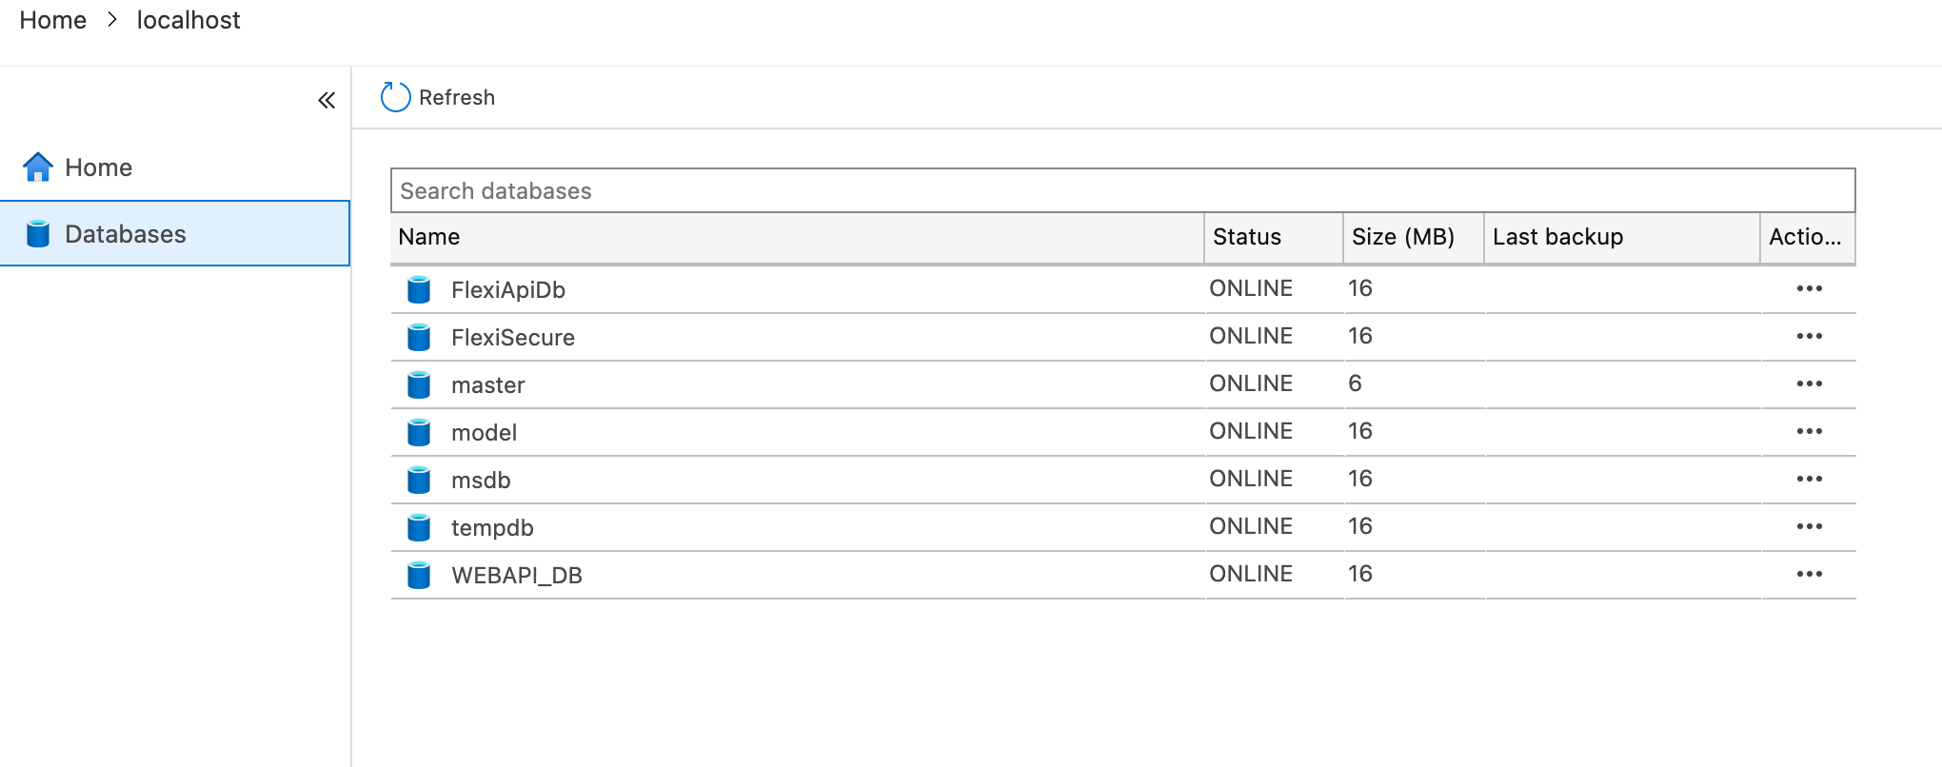
When you double click on the FlexiApiDb, this will open
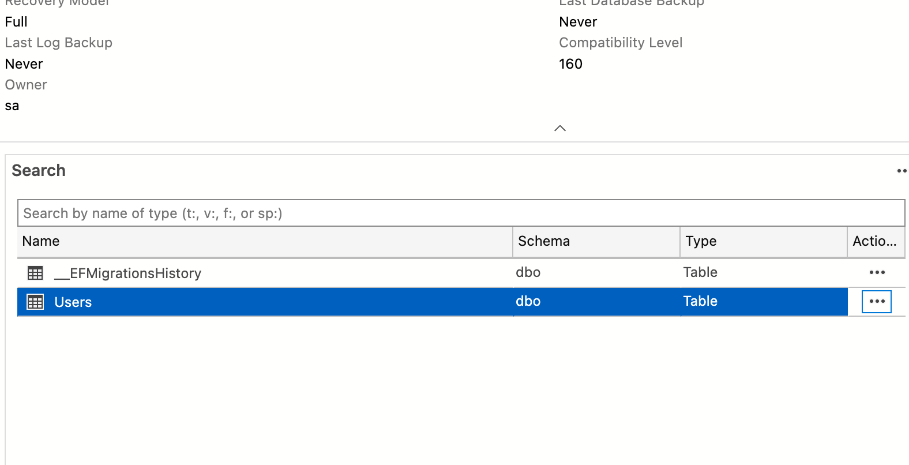
When you click on the three dot, this will open (...)

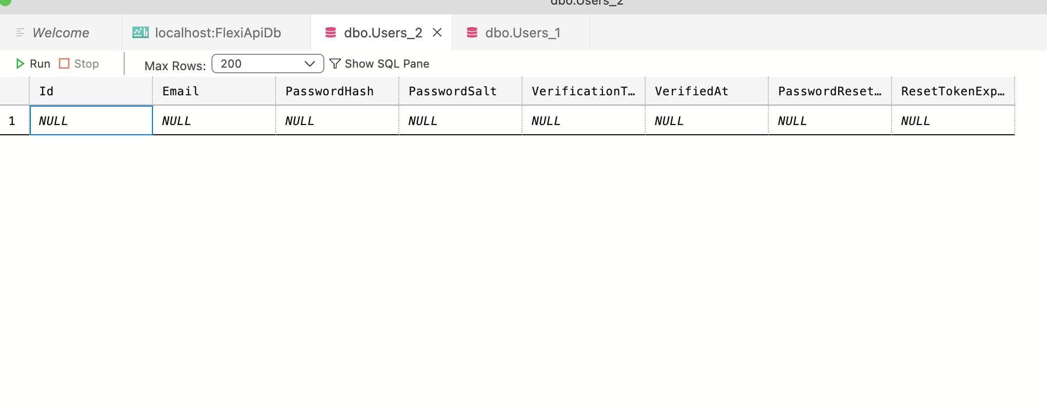
Step 5
Create a UserRegister.cs file in the model folder and paste the code in it
using System;
using System.Collections.Generic;
using System.ComponentModel.DataAnnotations;
using System.Linq;
using System.Threading.Tasks;

namespace FlexiSecure.Models
{
public class UserRegisterRequest
{
[Required,MinLength(3, ErrorMessage ="Enter a valid name")]
public string Name { get; set; } = string.Empty;
[Required, EmailAddress]
public string Email { get; set; } = string.Empty;
[Required, MinLength(6,ErrorMessage ="Please enter at least 6 characters ")]
public string Password { get; set; } = string.Empty;
[Required, Compare("Password")]
public string ConfirmPassword{get; set; } = string.Empty;

}
}

Step 6
The UserController.cs for the User Registration Will be like this
using System;
using System.Collections.Generic;
using System.Linq;
using System.Security.Cryptography;
using System.Threading.Tasks;
using Microsoft.AspNetCore.Mvc;

namespace FlexiSecure.Controllers
{
[ApiController]
[Route("api/[controller]")]
public class UserController : ControllerBase
{
private readonly DataContext _context;
public UserController(DataContext context)
{
_context = context;
}

[HttpPost("register")]
public async Task<IActionResult>Register(UserRegisterRequest request)
{

//Check if Email is already registered
if(_context.Users.Any(u=> u.Email == request.Email)){
return BadRequest();
};

//Create a Password Harsh
CreatePasswordHash(request.Password, out byte[]passwordHash,out byte[]passwordSalt);

//Call the user model from User.cs, create a new objects
var user = new User{
Name = request.Name,
Email = request.Email,
PasswordHash=passwordHash,
PasswordSalt = passwordSalt,
VerificationToken = CreateRandomToken(),
};

// The _context is called from the DataContext file and insiidde that file, we have the Users data set
//The Users dataset is using the User model
//We will the add the user object we created to the Users dataset
_context.Users.Add(user);
await _context.SaveChangesAsync();

return Ok("Hello "+request.Name+", successfully created");

}

private static void CreatePasswordHash(string password, out byte[] passwordHash, out byte[] passwordSalt)
{
using (var hmac = new HMACSHA512())
{
passwordSalt = hmac.Key;
passwordHash = hmac.ComputeHash(System.Text.Encoding.UTF8.GetBytes(password));

}

}

private string CreateRandomToken(){
return Convert.ToHexString(RandomNumberGenerator.GetBytes(64));
}

}
}

Step 7

Create a UserLoginRequest.cs model and add the following codes to it

using System;
using System.Collections.Generic;
using System.ComponentModel.DataAnnotations;
using System.Linq;
using System.Threading.Tasks;

namespace FlexiSecure.Models
{
public class UserLoginRequest
{

[Required, EmailAddress]
public string Email { get; set; } = string.Empty;
[Required]
public string Password { get; set; } = string.Empty;

}
}

Step 8
The UserController.cs at this stage will look like this

using System;
using System.Collections.Generic;
using System.Linq;
using System.Security.Cryptography;
using System.Threading.Tasks;
using Microsoft.AspNetCore.Mvc;

namespace FlexiSecure.Controllers
{
[ApiController]
[Route("api/[controller]")]
public class UserController : ControllerBase
{
private readonly DataContext _context;
public UserController(DataContext context)
{
_context = context;
}

[HttpPost("register")]
public async Task<IActionResult>Register(UserRegisterRequest request)
{

//Check if Email is already registered
if(_context.Users.Any(u=> u.Email == request.Email)){
return BadRequest();
};

//Create a Password Harsh
CreatePasswordHash(request.Password, out byte[]passwordHash,out byte[]passwordSalt);

//Call the user model from User.cs, create a new objects
var user = new User{
Name = request.Name,
Email = request.Email,
PasswordHash=passwordHash,
PasswordSalt = passwordSalt,
VerificationToken = CreateRandomToken(),
};

// The _context is called from the DataContext file and insiidde that file, we have the Users data set
//The Users dataset is using the User model
//We will the add the user object we created to the Users dataset
_context.Users.Add(user);
await _context.SaveChangesAsync();

return Ok("Hello "+request.Name+", successfully created");

}

[HttpPost("login")]
public async Task<IActionResult>Login(UserLoginRequest request)
{

var user = await _context.Users.FirstOrDefaultAsync(u => u.Email == request.Email);
if(user==null){
return BadRequest("User not found");
}

if(!VerifyPasswordHash(request.Password, user.PasswordHash, user.PasswordSalt))
{
return BadRequest("Password is incorrect");
}

if(user.VerifiedAt == null){
return BadRequest("User is not verified");
}
return Ok($"Welcome Back, {user.Email}! ");

}

private static bool VerifyPasswordHash(string password, byte[] passwordHash, byte[] passwordSalt)
{
using (var hmac = new HMACSHA512(passwordSalt))
{

var computedHash = hmac.ComputeHash(System.Text.Encoding.UTF8.GetBytes(password));
return computedHash.SequenceEqual(passwordHash);

}

}

private static void CreatePasswordHash(string password, out byte[] passwordHash, out byte[] passwordSalt)
{
using (var hmac = new HMACSHA512())
{
passwordSalt = hmac.Key;
passwordHash = hmac.ComputeHash(System.Text.Encoding.UTF8.GetBytes(password));

}

}

private string CreateRandomToken(){
return Convert.ToHexString(RandomNumberGenerator.GetBytes(64));
}

}
}

Step 9
After creating our users, we can verify them by sending a token to their account.
The verify user code in the controller will be

using System;
using System.Collections.Generic;
using System.Linq;
using System.Security.Cryptography;
using System.Threading.Tasks;
using Microsoft.AspNetCore.Mvc;

namespace FlexiSecure.Controllers
{
[ApiController]
[Route("api/[controller]")]
public class UserController : ControllerBase
{
private readonly DataContext _context;
public UserController(DataContext context)
{
_context = context;
}

[HttpPost("register")]
public async Task<IActionResult>Register(UserRegisterRequest request)
{

//Check if Email is already registered
if(_context.Users.Any(u=> u.Email == request.Email)){
return BadRequest();
};

//Create a Password Harsh
CreatePasswordHash(request.Password, out byte[]passwordHash,out byte[]passwordSalt);

//Call the user model from User.cs, create a new objects
var user = new User{
Name = request.Name,
Email = request.Email,
PasswordHash=passwordHash,
PasswordSalt = passwordSalt,
VerificationToken = CreateRandomToken(),
};

// The _context is called from the DataContext file and insiidde that file, we have the Users data set
//The Users dataset is using the User model
//We will the add the user object we created to the Users dataset
_context.Users.Add(user);
await _context.SaveChangesAsync();

return Ok("Hello "+request.Name+", successfully created");

}

[HttpPost("login")]
public async Task<IActionResult>Login(UserLoginRequest request)
{

var user = await _context.Users.FirstOrDefaultAsync(u => u.Email == request.Email);
if(user==null){
return BadRequest("User not found");
}

if(!VerifyPasswordHash(request.Password, user.PasswordHash, user.PasswordSalt))
{
return BadRequest("Password is incorrect");
}

if(user.VerifiedAt == null){
return BadRequest("User is not verified");
}

return Ok($"Welcome Back, {user.Email}! ");

}

[HttpPost("verify")]
public async Task<IActionResult>Verify(string token)
{

var user = await _context.Users.FirstOrDefaultAsync(u => u.VerificationToken == token);
if(user==null){
return BadRequest("Invalid token");
}

user.VerifiedAt = DateTime.Now;
await _context.SaveChangesAsync();

return Ok("Congratulations! You have been verified");

}

private static bool VerifyPasswordHash(string password, byte[] passwordHash, byte[] passwordSalt)
{
using (var hmac = new HMACSHA512(passwordSalt))
{

var computedHash = hmac.ComputeHash(System.Text.Encoding.UTF8.GetBytes(password));
return computedHash.SequenceEqual(passwordHash);

}

}

private static void CreatePasswordHash(string password, out byte[] passwordHash, out byte[] passwordSalt)
{
using (var hmac = new HMACSHA512())
{
passwordSalt = hmac.Key;
passwordHash = hmac.ComputeHash(System.Text.Encoding.UTF8.GetBytes(password));

}

}

private string CreateRandomToken(){
return Convert.ToHexString(RandomNumberGenerator.GetBytes(64));
}

}
}

